**1. System Preparation**

**2. Create Hadoop User and Enable SSH**

* Create a Hadoop User with Sudo Privileges

* Enable Passwordless SSH for the Hadoop User

**3. Download and Install Hadoop**

* Download Hadoop  
  A computer screen with white text

  Description automatically generated
* Extract and Move Hadoop to /usr/local/Hadoop  
  A computer screen with white text

  Description automatically generated

**4. Configure Hadoop Environment**

* Set Environment Variables in .bashrc

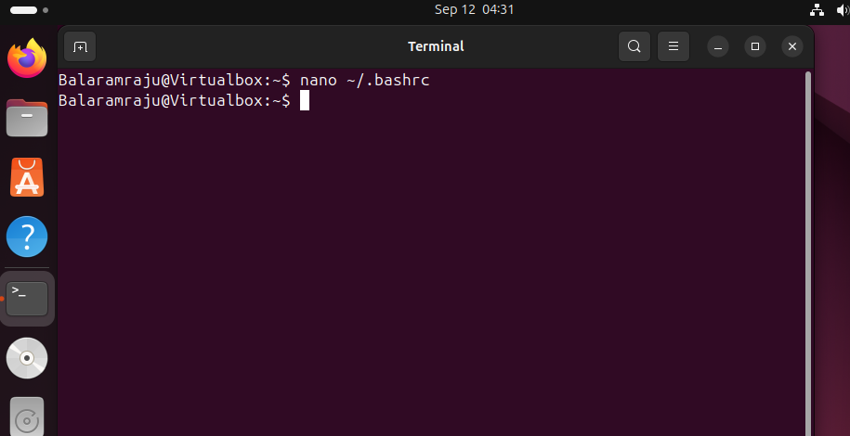

* Update Configuration Files (core-site.xml, hdfs-site.xml, mapred-site.xml, and yarn-site.xml)

**5. Format and Start Hadoop Services**

* Format the Namenode
* A screenshot of a computer program

  Description automatically generated

**6. Test Hadoop Setup**

* Run a Word Count Example Using Hadoop MapReduce
* A computer screen shot of a program

  Description automatically generated